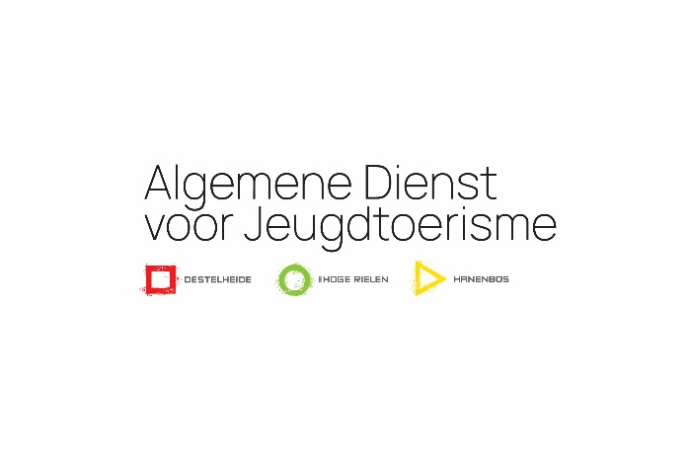
PRIVACY STATEMENT
October 2020
(Version 2)

Algemene Dienst Jeugdtoerisme vzw (ADJ) – General Service for Youth Tourism, a non-profit organisation

ADJ vzw (non-profit) manages the accommodation domains the de Hoge Rielen in Kasterlee (dHR) and Destelheide-Hanenbos in Dworp (DH-HB), Belgium. The provisions of this privacy statement apply to all entities of our organisation.
ADJ vzw attaches great importance to the protection of your personal data. In this privacy statement, we want to provide clear and transparent information about how we handle your personal data. We do everything we can to guarantee your privacy and, therefore, handle personal data with great care.
In all cases, ADJ vzw complies with the applicable laws and regulations, including the General Data Protection Regulation (AVG or GDPR) .
This entails that:
- we process your personal data in accordance with the purpose for which it was provided. These purposes and type of personal data are described in this privacy statement;
- the processing of your personal data is limited to those data that are minimally necessary for the purposes for which they are processed;
- we ask for your explicit consent if we need it for the processing of your personal data;
- we have taken appropriate technical and organisational measures to ensure the security of your personal data;
- we do not pass on personal data to third parties, unless this is necessary for the purposes for which the data is provided;
- we are aware of your rights regarding your personal data, we wish to inform you of them and respect them.

General
ADJ vzw is responsible for the processing of your personal data. If, after reading our privacy statement, or in a more general sense, you have any questions about this or wish to contact us, please do so via the contact details below:
Algemene Dienst Jeugdtoerisme vzw
Molenstraat 62
2460 Kasterlee
info@adj.be

Why do we process your personal data?
Your personal data will be processed by ADJ vzw in function of the following purposes and legal grounds:
- to organise, prepare and invoice your stay (legal basis: execution of the agreement);
- to be able to contact you before, during or after your stay (legal basis: execution of the agreement);
- for the delivery of products and services ordered by you (legal basis: performance of the agreement);
- to keep you informed of our offer via newsletters and invitations, campaigns and promotions as well as direct marketing (legal basis: subject to the consent of the person concerned);
- to use images for social media, printed matter, on the website, etc. (legal basis: subject to the consent of the person concerned);
- for the inclusion of personal data in anonymous statistics, from which the identity of specific persons or companies cannot be ascertained, in order to continuously improve our services as well as to comply with our legal obligations (legal basis: legal obligation).

For the above purposes, we may request, store, collect and process the following personal data from you:
- personal identity data: name, first name, address, telephone or mobile number, e-mail;
- date of birth and/or age;
- account number and/or financial details;
- images.
We only use the data collected for the purposes for which we obtained the data.

Is your data passed on to third parties?
We may disclose the information you provide to us to third parties if this is necessary for the performance of the purposes described above.

For example, we use a third party for:
- taking care of the internet environment (web hosting);
- providing ICT infrastructure and cloud systems;
- providing and distributing newsletters and invitations;
- providing the necessary insurance;
- possible financial follow-up of your file.

We never pass on personal data to other parties with whom we have not concluded a processing agreement and/or with whom we have made the necessary arrangements to guarantee the security of your personal data.
Furthermore, we will not pass on the information you provide to third parties unless this is required and permitted by law.
We may also share personal data with third parties if you give us permission to do so. You have the right to withdraw this consent at any time, without prejudice to the lawfulness of the processing for the withdrawal. We do not provide personal data to parties located outside the EU.

Minors
We only process personal data of minors (persons under the age of 16) if written consent has been given by the parent or legal representative.

Retention period
ADJ vzw does not retain personal data longer than necessary for the purpose for which it was provided or based on what is required by law.

Data security
We have taken appropriate technical and organisational measures to protect your personal data against destruction, loss, falsification, alteration, unauthorised access or accidental disclosure to third parties as well as any other unlawful processing of such data.

Cookies
A "cookie" is a small file sent by our server and placed on the hard drive of your device (computer, tablet or smartphone). The information stored on these cookies can only be read by us and only for the duration of the visit to our website.

Our website uses cookies and similar technologies to distinguish your usage preferences from those of other users of our website. This helps us to provide you with a better user experience when you visit our website and also allows us to optimise our website.

We are required to ask for your consent to use or store cookies and similar technologies on your computers or mobile devices. This cookie policy gives you clear and complete information about the cookies we use and their purposes.
Our websites use the following cookies:

Name | Provider | Type | Category | Expires
language | .dehogerielen.be | First party | Functional | After 1 month
PHPSESSID | www.dehogerielen.be | First party | Necessary | End of session
PHPSESSID | dehogerielen.be | First party | Necessary | End of session
_ga | .dehogerielen.be | First party | Analytical | After 1 year
_gat | .dehogerielen.be | First party | Analytical | After 10 minutes
_gid | .dehogerielen.be | First party | Analytical | After 1 year

The de Hoge Rielen order program uses the following cookies:
- Session: https://laravel.com/docs/5.4/session
- ECSRF Protection: https://laravel.com/docs/5.4/csrf
- Remember me: https://laravel.com/docs/5.4/authentication#remembering-users

On your first visit to our websites, you will be informed about the use of cookies which you may accept or refuse.
You can refuse or block cookies by changing the configuration parameters of your navigation system. Disabling cookies may mean that you are unable to use certain functionalities of the website.
More information about cookies can be found at: http://www.allaboutcookies.org/
For cookies placed by third parties (including Google Analytics), we would like to refer you to the statements that these parties provide on their respective websites. Please note: we have no influence whatsoever on the content of these statements, nor on the content of the cookies of these third parties: Google Analytics cookies.

Facebook Pixel
This website uses Facebook Pixel, an analysis tool from Facebook. This tool helps us to analyse the website, which in turn helps us to improve the Facebook experience of our users. The information generated by this cookie is sent and stored on Facebook's servers. Facebook uses this data to create bulk reports on the site usage of all users, without your IP address. The cookie only stores information such as: which Facebook users visit the website, which pages do these users visit, etc. This pixel also tracks the behaviour of users after seeing or clicking a Facebook ad. In this way, Facebook evaluates the effectiveness of advertisements. Thanks to the pixel, it is also possible for us to show website visitors an advertisement on the Facebook platform. The data obtained is anonymous to us and does not provide us with any further information about your identity as a user. However, the data is stored by Facebook and processed in such a way that it can be linked to a specific user profile. Facebook may, therefore, use the data for its own advertising purposes, in accordance with Facebook's privacy policy.
Your rights concerning your data
You have the right to inspect and correct or delete the personal data that we have received from you.

You can also object to the processing of your personal data (or part thereof) by us or by one of our processors.

You also have the right to have the data provided by you transferred by us to yourself or on your instructions directly to another party.

Insofar as the processing is based on your prior consent, you always have the right to revoke that consent.
At the start of this privacy statement, you will find information on how to contact us.
ADJ vzw will make all reasonable efforts to comply with your request, provided it is in accordance with the applicable laws and regulations. We may ask you to identify yourself before we can respond to your request.

The processing of your personal data does not include profiling and will not be subject to automated decisions by ADJ vzw.

Complaints
If you have a complaint about the processing of your personal data, we ask you to contact us directly via info@adj.be.

In addition, you always have the right to file a complaint with the Privacy Commission, the supervisory authority in the field of privacy protection:

Commissie voor de Bescherming van de Persoonlijke Levenssfeer (Commission for data protection)
Drukpersstraat 35
1000 Brussel
+32 (0)2 274 48 00 (tel)
+32 (0)2 274 48 35 (fax)
commission@privacycommission.be

Changes to this privacy statement
ADJ vzw can change its privacy statement. We will announce this change on our websites. At that time, older versions of our privacy statement will be stored in our archive. If you want to consult them, please send us an email at info@adj.be.

You can find this privacy statement at https://www.dehogerielen.be/nl/cookies-policy/, https://www.destelheide.be/nl/cookies-policy/ and https://www.hanenbos.be/nl/cookies-policy/.

Regulation (EU) 2016/679 of the European Parliament and of the Council of 27 April 2016 on the protection of natural persons with regard to the processing of personal data and on the free movement of such data, and repealing Directive 95/45/EC (General Data Protection Regulation)

